SQL ASSIGNMENT SOLUTIONS

-- Q1. Basic Filtering – High-Value Products
-- Find all event records where the base_price is greater than 1,000.
-- Display:
-- - event_id
-- - store_id
-- - product_code
-- - base_price
-- - promo_type
-- Concepts:
-- SELECT, WHERE, comparison operators.

Select Event_id, Store_id, Product_code, Base_Price, Promo_type
From Fact_Events
Where Base_Price > 1000;
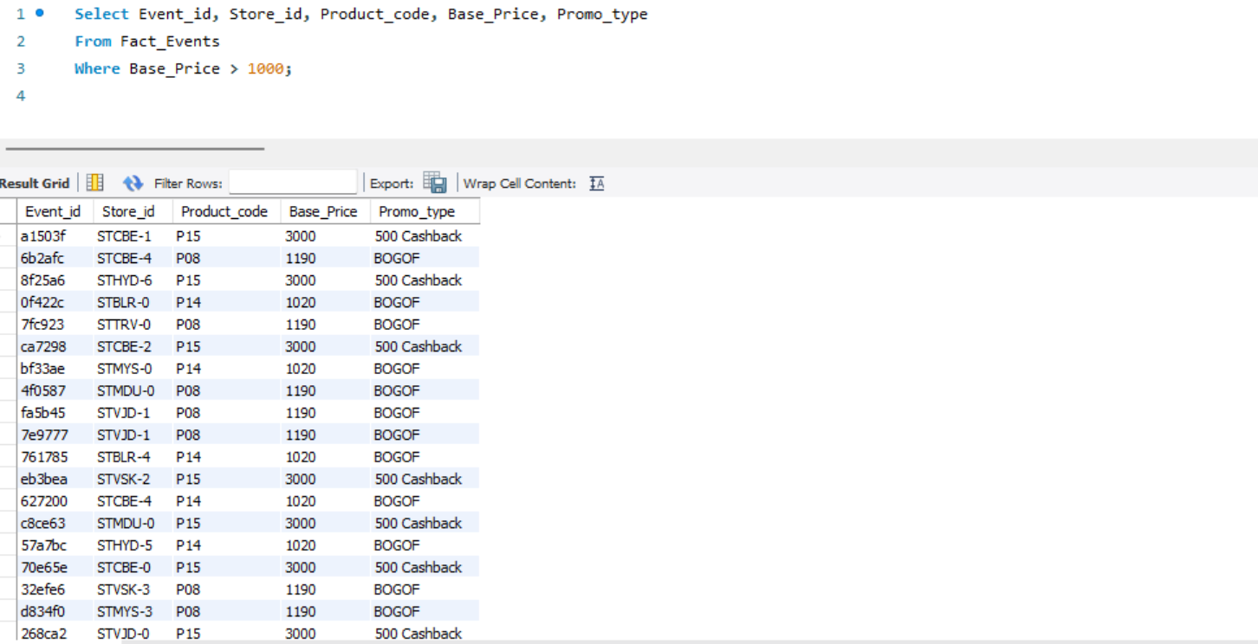

-- ------------------------------------------------------------
-- Q2. Sorting Promotional Events
-- Display all events where quantity sold after the promotion was greater than 100.
-- Display:
-- - event_id
-- - product_code
-- - promo_type
-- - quantity_sold(before_promo)
-- - quantity_sold(after_promo)
-- Sort by quantity_sold(after_promo) in descending order.
-- Concepts:
-- WHERE, ORDER BY, DESC.

Select event_id, product_code, promo_type, `quantity_sold(before_promo)`, `quantity_sold(after_promo)`
From Fact_Events
Where `quantity_sold(after_promo)` > 100
Order by `quantity_sold(after_promo)` Desc;
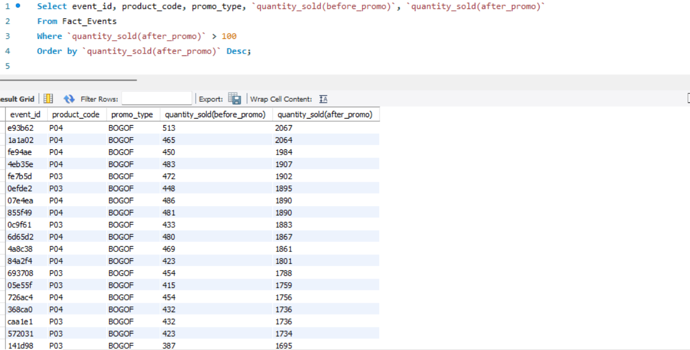
-- ------------------------------------------------------------

-- Q3. DISTINCT Promotion Types
-- Find all unique promotion types used in the dataset.
-- Display only the unique promo_type values.
-- Concepts:
-- DISTINCT.

Select Distinct(Promo_Type)
From Fact_Events;
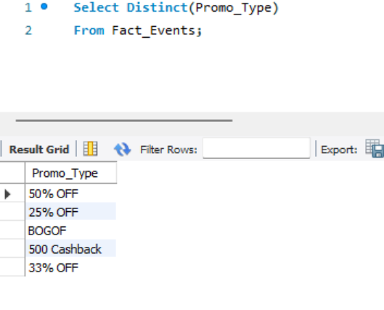
-- ------------------------------------------------------------

-- Q4. Basic Aggregation
-- Calculate the following for the complete fact_events table:
-- - Total number of events
-- - Total quantity sold before promotion
-- - Total quantity sold after promotion
-- - Average base price
-- - Maximum base price
-- - Minimum base price
-- Return all metrics in one row.
-- Concepts:
-- COUNT, SUM, AVG, MAX, MIN

Select Count(event_id) as Total_Events, Sum(`quantity_sold(before_promo)`) as Total_Qty_Before_Promo, Sum(`quantity_sold(after_promo)`) as Total_Qty_After_Promo, Avg(base_Price) as Avg_Base_price, Max(base_price) as Max_Base_price, Min(Base_price) as Min_Base_price
From Fact_Events;
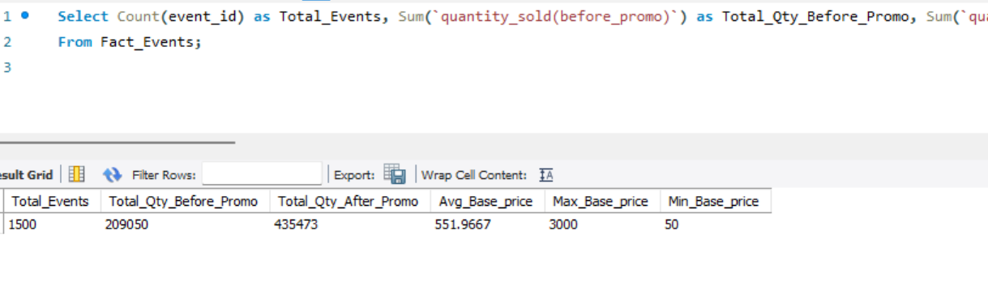
-- -------------------------------------------------------------------------------
-- Q5. Sales Volume by Promotion Type
-- For each promo_type, calculate:
-- - Number of events
-- - Total quantity sold before promotion
-- - Total quantity sold after promotion
-- Sort by total quantity sold after promotion in descending order.
-- Concepts:
-- GROUP BY, COUNT, SUM, ORDER BY.

Select Promo_type, Count(event_id) as Number_of_events, Sum(`quantity_sold(before_promo)`) as Total_Qty_Before_Promo, Sum(`quantity_sold(after_promo)`) as Total_Qty_After_Promo
From Fact_Events
Group By Promo_type
Order By Total_Qty_After_Promo;
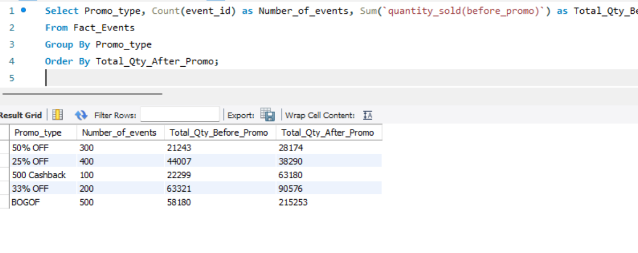
-- ------------------------------------------------------------

-- Q6. Promotion Uplift
-- For every promotion type, calculate:
-- - Total quantity before promotion
-- - Total quantity after promotion
-- - Quantity increase/decrease
-- Use:
-- Quantity Change = After Promo Quantity - Before Promo Quantity
-- Display:
-- - promo_type
-- - total_before
-- - total_after
-- - quantity_change
-- Sort by quantity_change descending.
-- Concepts:
-- GROUP BY, SUM, arithmetic calculations, aliases.

select
promo_type,
SUM(`quantity_sold(before_promo)`) as Total_before,
SUM(`quantity_sold(after_promo)`) as Total_after,
(SUM(`quantity_sold(after_promo)`) - SUM(`quantity_sold(before_promo)`)) as Quantity_change
from fact_events
group by promo_type
order by Quantity_change desc;
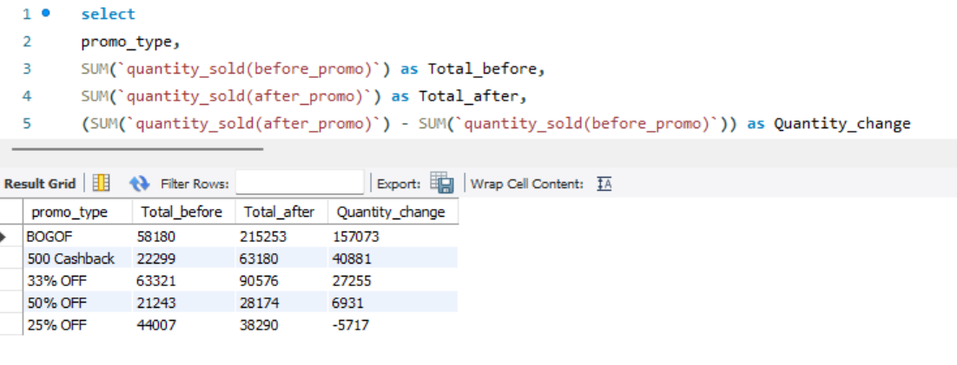
-- ------------------------------------------------------------

-- Q7. Product Performance
-- Using fact_events and dim_products, calculate total quantity sold after promotion for every product.
-- Display:
-- - product_code
-- - product_name
-- - category
-- - total quantity after promotion
-- Sort by total quantity after promotion descending.
-- Concepts:
-- INNER JOIN, GROUP BY, SUM, ORDER BY.

select
pro.product_code,
pro.product_name,
pro.category,
SUM(eve.`quantity_sold(after_promo)`) as Total_after
from fact_events eve
inner join dim_products pro on pro.product_code = eve.product_code
group by pro.product_code, pro.product_name, pro.category
order by Total_after desc;
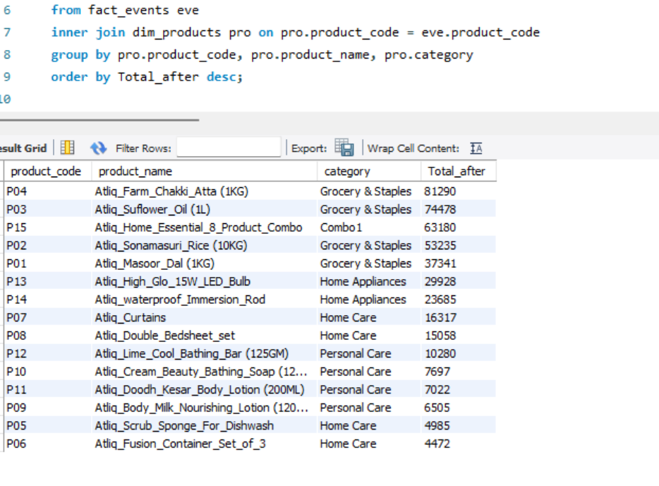
-- ------------------------------------------------------------

-- Q8. Category-Level Performance
-- Using fact_events and dim_products, calculate for every product category:
-- - Number of events
-- - Total quantity before promotion
-- - Total quantity after promotion
-- - Quantity change
-- Sort categories by total quantity after promotion descending.
-- Concepts:
-- JOIN, GROUP BY, SUM, COUNT, arithmetic calculations.

Select P.Product_Name, Count(F.event_id) as Number_of_events, Sum(F.`quantity_sold(before_promo)`) as Total_Qty_Before_Promo, Sum(F.`quantity_sold(after_promo)`) as Total_Qty_After_Promo, (Sum(F.`quantity_sold(after_promo)`) - Sum(F.`quantity_sold(before_promo)`)) as Quantity_Change
From Fact_events as F Join Dim_Products as P
On F.Product_code = P.Product_code
Group By P.Product_code
Order By Total_Qty_After_Promo Desc;
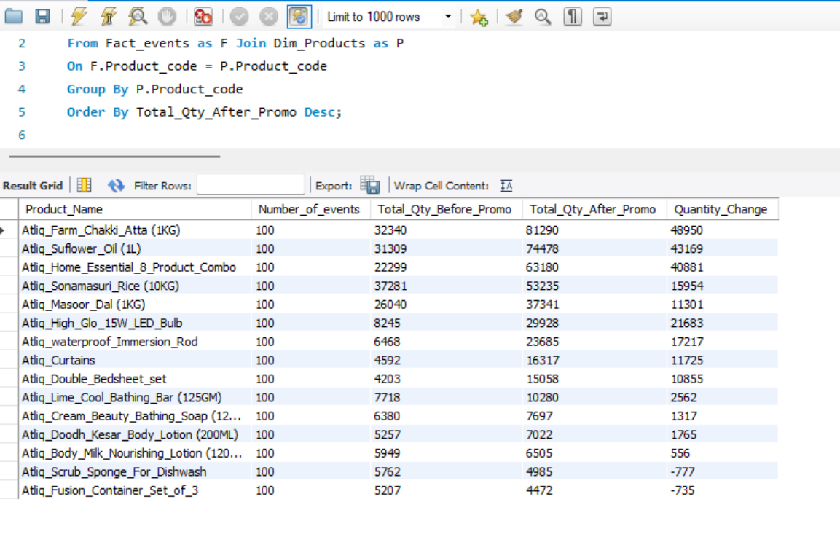

-- ------------------------------------------------------------

-- Q9. Store Performance
-- Using fact_events and dim_stores, calculate for every city:

-- - Number of promotional events
-- - Total quantity before promotion
-- - Total quantity after promotion

-- Display:
-- - city
-- - event_count
-- - total_before
-- - total_after
-- Sort cities by total_after descending.
-- Concepts:
-- JOIN, GROUP BY, aggregation, ORDER BY.

Select S.City, Count(F.event_id) as Number_of_events, Sum(F.`quantity_sold(before_promo)`) as Total_Qty_Before_Promo, Sum(F.`quantity_sold(after_promo)`) as Total_Qty_After_Promo
From Fact_events as F Join Dim_stores as S
On F.Store_id = S.Store_id
Group By S.City
Order By Total_Qty_Before_Promo Desc;
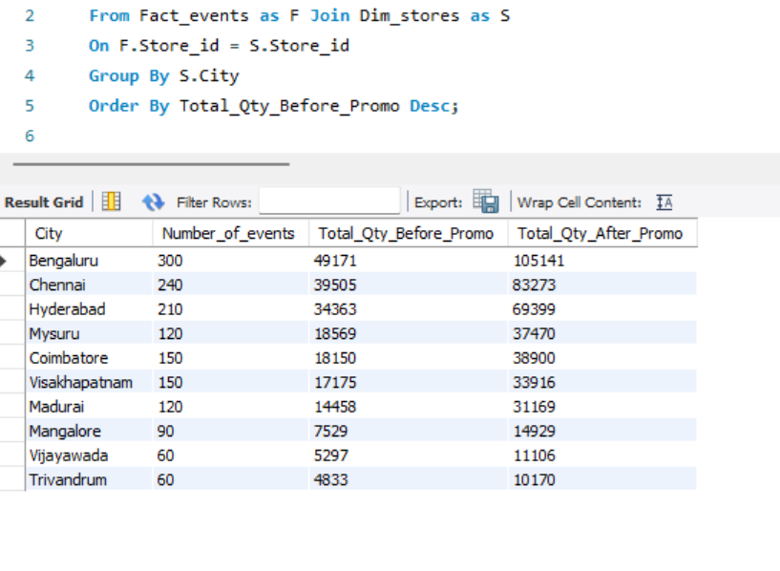
-- ------------------------------------------------------------

-- Q10. Campaign Performance
-- Using fact_events and dim_campaigns, calculate for each campaign:
-- - Campaign name
-- - Start date
-- - End date
-- - Number of events
-- - Total quantity before promotion
-- - Total quantity after promotion
-- Sort by total quantity after promotion descending.
-- Concepts:
-- JOIN, GROUP BY, date columns, aggregation.

Select C.Campaign_Name, C.Start_date, C.End_Date, Count(F.event_id) as Number_of_events, Sum(F.`quantity_sold(before_promo)`) as Total_Qty_Before_Promo, Sum(F.`quantity_sold(after_promo)`) as Total_Qty_After_Promo
From Fact_events as F Join Dim_Campaigns as C
On F.Campaign_ID = C.Campaign_ID
Group By C.Campaign_Name
Order By Total_Qty_After_Promo Desc;
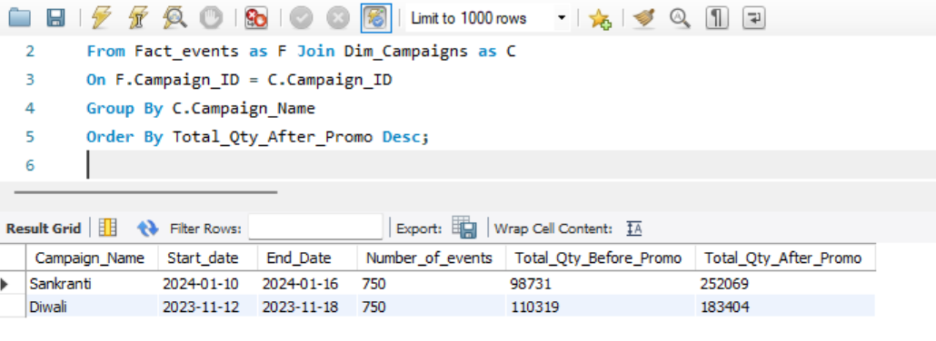

-- ------------------------------------------------------------

-- Q11. Product Category with HAVING
-- Find product categories where the total quantity sold after promotion is greater than 1,000.
-- Display:
-- - category
-- - total quantity after promotion
-- - average base price
-- Sort by total quantity after promotion descending.
-- Concepts:
-- JOIN, GROUP BY, HAVING, AVG, SUM.

Select P.Category, Sum(F.`quantity_sold(after_promo)`) as Total_Qty_After_Promo, Avg(F.Base_Price) as Avg_Base_Price
From Fact_events as F Join Dim_Products as P
On F.Product_code = P.Product_code
Group By P.Category
Having Total_Qty_After_Promo > 1000
Order By Total_Qty_After_Promo Desc;
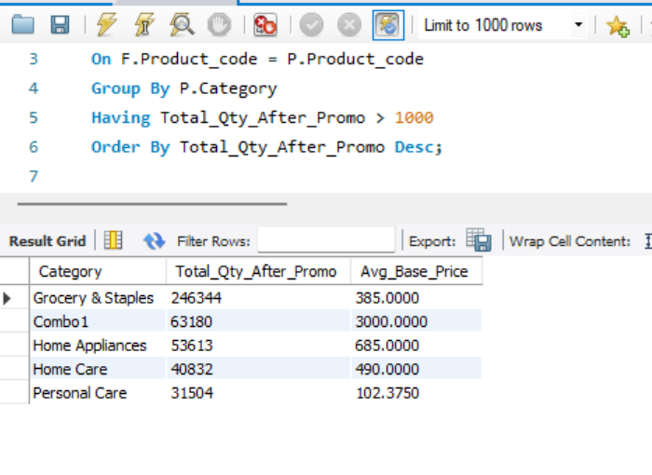
-- ------------------------------------------------------------

-- Q12. Store + Category Analysis
-- Using fact_events, dim_stores and dim_products, calculate total quantity sold after promotion for every combination of:
-- - City
-- - Product category
-- Display:
-- - city
-- - category
-- - total quantity after promotion
-- Sort first by city and then by total quantity descending.
-- Concepts:
-- Multiple JOINs, GROUP BY, ORDER BY.

Select S.City, P.Category, Sum(F.`quantity_sold(after_promo)`) as Total_Qty_After_Promo
From Dim_Stores as S Join Dim_Products as P Join Fact_Events as F
On S.Store_id = F.Store_id and P.Product_code = F.Product_code
Group By S.City, P.Category
Order By S.City Desc, Total_Qty_After_Promo Desc
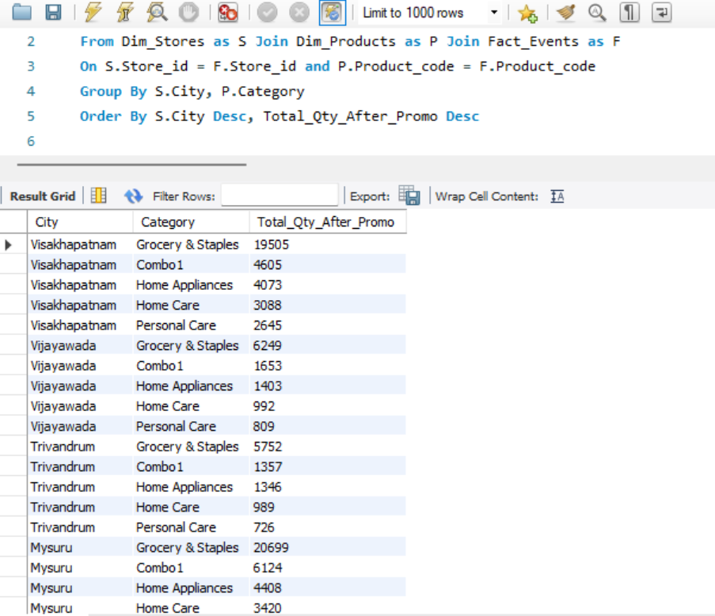
-- ------------------------------------------------------------

-- Q13. Promotion Effectiveness by Product
-- For each product, calculate:
-- - Product name
-- - Category
-- - Total quantity before promotion
-- - Total quantity after promotion
-- - Quantity change
-- - Percentage change
-- Use:
-- Percentage Change =
-- ((After Promo - Before Promo) / Before Promo) * 100
-- Handle division by zero appropriately.
-- Sort by percentage change descending.
-- Concepts:
-- JOIN, GROUP BY, arithmetic calculations, NULLIF, percentage calculations.

Select P.Product_Name, P.Category, Sum(F.`quantity_sold(before_promo)`) as Total_Qty_Before_Promo, Sum(F.`quantity_sold(after_promo)`) as Total_Qty_After_Promo, (Sum(F.`quantity_sold(after_promo)`) - Sum(F.`quantity_sold(before_promo)`)) as Quantity_Change, (( Sum(F.`quantity_sold(after_promo)`)- Sum(F.`quantity_sold(before_promo)`))/ NULLIF(Sum(F.`quantity_sold(before_promo)`),0)*100) as Percentage_Change
From Fact_events as F Join Dim_Products as P
On F.Product_code = P.Product_code
Group By P.Product_Name
Order By Percentage_Change Desc;
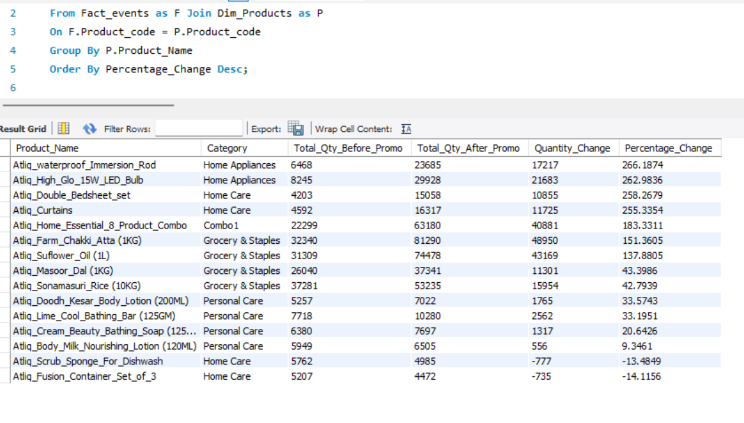
-- ------------------------------------------------------------

-- Q14. Campaign and Promotion Type Analysis
-- For each campaign and promo_type combination, calculate:
-- - Number of events
-- - Total quantity before promotion
-- - Total quantity after promotion
-- - Quantity change
-- Display:
-- - campaign_name
-- - promo_type
-- - event_count
-- - total_before
-- - total_after
-- - quantity_change
-- Sort by campaign_name and quantity_change descending.
-- Concepts:
-- Multiple GROUP BY columns, JOIN, aggregation, ORDER BY.

Select C.Campaign_Name, F.Promo_type, Count(F.event_id) as Number_of_events, Sum(F.`quantity_sold(before_promo)`) as Total_Qty_Before_Promo, Sum(F.`quantity_sold(after_promo)`) as Total_Qty_After_Promo, (Sum(F.`quantity_sold(after_promo)`) - Sum(F.`quantity_sold(before_promo)`)) as Quantity_Change
From Fact_events as F Join Dim_Campaigns as C
On F.Campaign_id = C.Campaign_id
Group By C.Campaign_Name, F.Promo_type
Order By C.Campaign_Name Desc,Quantity_Change Desc;
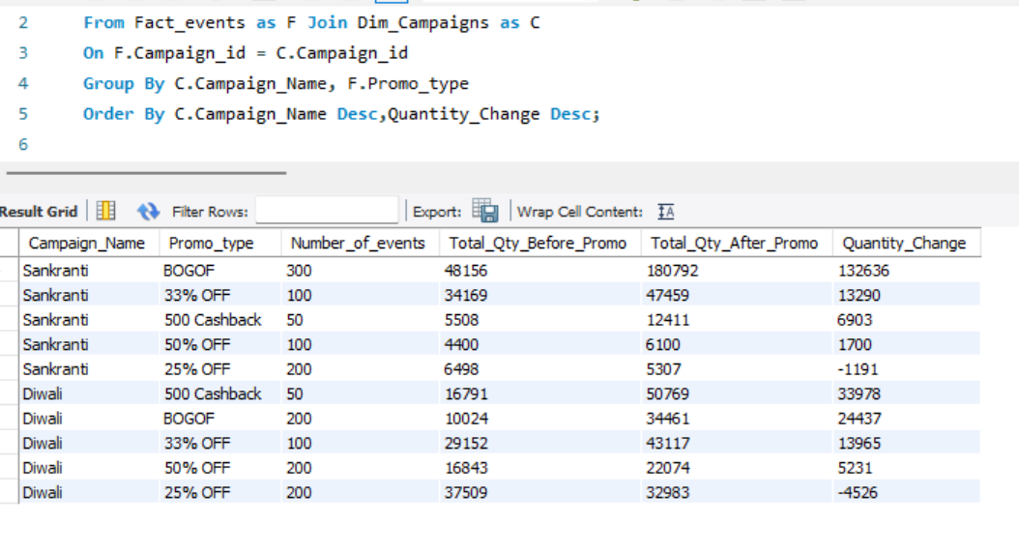
-- ------------------------------------------------------------

-- Q15. Product Revenue Before and After Promotion
-- For each product, calculate:
-- 1. Revenue before promotion =
-- base_price × quantity_sold(before_promo)
-- 2. Revenue after promotion =
-- base_price × quantity_sold(after_promo)
-- 3. Revenue difference =
-- Revenue after - Revenue before
-- Display:
-- - product_name
-- - category
-- - revenue_before
-- - revenue_after
-- - revenue_difference
-- Sort by revenue_difference descending.
-- Concepts:
-- JOIN, GROUP BY, SUM, arithmetic calculations, aliases.

Select P.Product_Name, P.Category, (F.Base_Price * F.`quantity_sold(before_promo)`) as Revenue_before_promotion, (F.Base_Price * F.`quantity_sold(after_promo)`) as Revenue_After_promotion, ((F.Base_Price * F.`quantity_sold(after_promo)`) - (F.Base_Price * F.`quantity_sold(before_promo)`)) as Revenue_difference
From Fact_events as F Join Dim_Products as P
On F.Product_code = P.Product_code
Group By P.Product_Name
Order By Revenue_difference Desc;
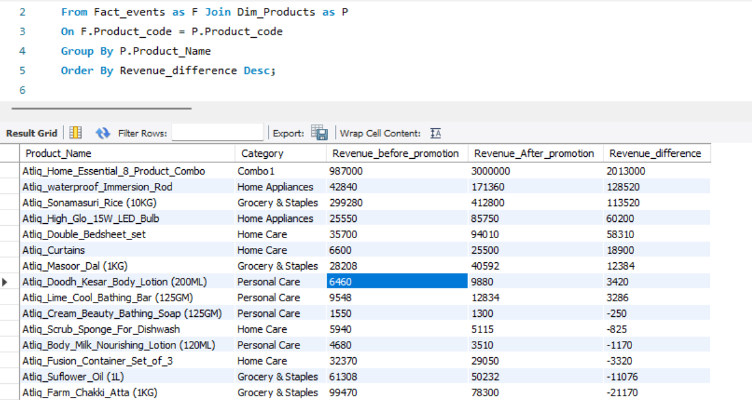
-- ------------------------------------------------------------

-- Q16. Classify Promotion Performance
-- For every promotion type, calculate total quantity before and after promotion.
-- Then classify the promotion using CASE:
-- - Percentage change >= 50% → "High Impact"
-- - Percentage change >= 20% → "Medium Impact"
-- - Percentage change < 20% → "Low Impact"
-- Display:
-- - promo_type
-- - total_before
-- - total_after
-- - percentage_change
-- - performance_category
-- Sort by percentage_change descending.
-- Concepts:
-- GROUP BY, CASE, arithmetic calculations, NULLIF, aliases.

Select Promo_Type, Sum(`quantity_sold(before_promo)`) as Total_Qty_Before_Promo, Sum(`quantity_sold(after_promo)`) as Total_Qty_After_Promo, (( Sum(`quantity_sold(after_promo)`)- Sum(`quantity_sold(before_promo)`))/ NULLIF(Sum(`quantity_sold(before_promo)`),0)*100) as Percentage_Change,
Case
When (( Sum(`quantity_sold(after_promo)`) - Sum(`quantity_sold(before_promo)`))/ NULLIF(Sum(`quantity_sold(before_promo)`),0)*100) >= 50 Then "High Impact"
When (( Sum(`quantity_sold(after_promo)`) - Sum(`quantity_sold(before_promo)`))/ NULLIF(Sum(`quantity_sold(before_promo)`),0)*100) >= 20 Then "Medium Impact"
Else "Low Impact"
End as performance_category
From Fact_Events
Group By Promo_Type;
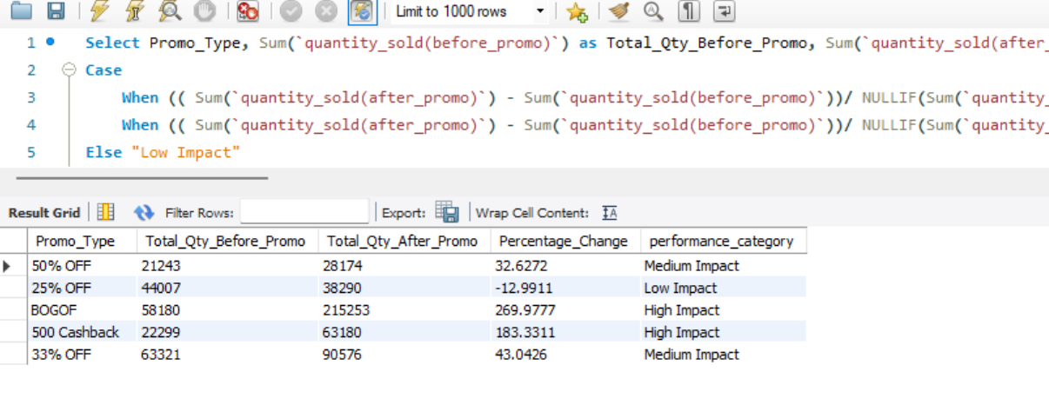
-- ------------------------------------------------------------

-- Q17. Top Products Within Each Category
-- Using a CTE:
-- 1. Calculate total quantity sold after promotion for every product.
-- 2. Rank products within each category based on total quantity sold after promotion.
-- 3. Return only the top 2 products from every category.
-- Display:
-- - category
-- - product_name
-- - total_quantity_after
-- - category_rank
-- Concepts:
-- CTE, JOIN, GROUP BY, DENSE_RANK/ROW_NUMBER,
-- PARTITION BY, window functions.

With
Temp as
(Select P.Category, P.Product_Name, Sum(F.`quantity_sold(after_promo)`) as Total_Qty_After_Promo
From Dim_Products as P Join Fact_Events as F
On P.Product_Code = F.Product_Code
Group By P.Category, P.Product_Name),
rn as
( Select Category, Product_Name, Total_Qty_After_Promo, Dense_rank() Over(Partition By Category order By Total_Qty_After_Promo ) as category_rank
From Temp)
Select Category, Product_Name, Total_Qty_After_Promo, category_rank From rn where category_rank <= 2 order by Total_Qty_After_Promo;
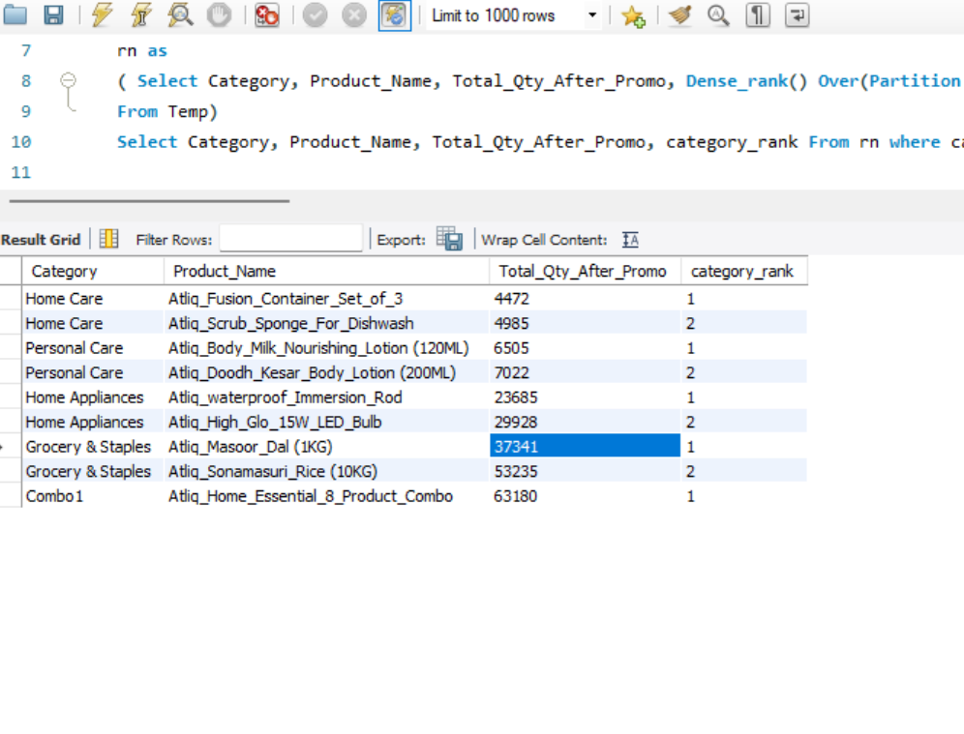

-- ------------------------------------------------------------

-- Q18. Best-Performing Stores Within Each City
-- Calculate total quantity sold after promotion for each store.
-- Join dim_stores to obtain the city.
-- Then rank stores within each city based on total quantity sold after promotion.
-- Return the top 2 stores from each city.
-- Display:
-- - city
-- - store_id
-- - total_quantity_after
-- - city_rank
-- Concepts:
-- JOIN, CTE, GROUP BY, window functions,
-- PARTITION BY, RANK/DENSE_RANK.

With
Temp as
(Select S.City, S.Store_id, Sum(F.`quantity_sold(after_promo)`) as Total_Qty_After_Promo
From Dim_Stores as S Join Fact_Events as F
On S.Store_id = F.Store_id
Group By S.Store_id,S.city),
rank_table as
(Select City, Store_id, Total_Qty_After_Promo, Dense_rank() over(Partition by City order by Total_Qty_After_Promo) as city_rank From Temp)
Select City, Store_id, Total_Qty_After_Promo, city_rank From rank_table Where City_rank <= 2;
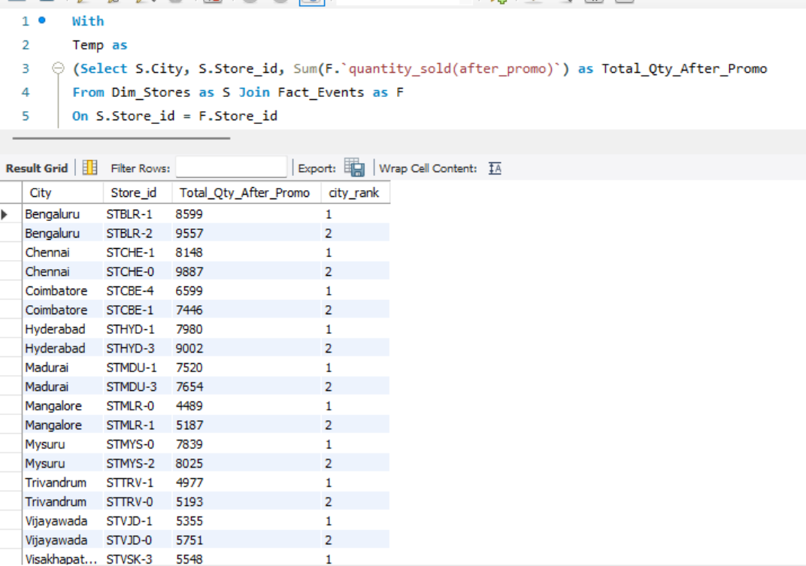
-- ------------------------------------------------------------
-- Q19. Campaign-Level Product Performance
-- For every campaign and product:
-- Calculate:
-- - Total quantity before promotion
-- - Total quantity after promotion
-- - Quantity change
-- - Percentage change
-- Then rank products within each campaign based on percentage change.
-- Return the top 3 products for every campaign.
-- Display:
-- - campaign_name
-- - product_name
-- - total_before
-- - total_after
-- - quantity_change
-- - percentage_change
-- - campaign_rank
-- Concepts:
-- Multiple JOINs, CTE, GROUP BY, arithmetic calculations,
-- NULLIF, window functions, PARTITION BY, ranking.

With Temp as
(Select C.Campaign_Name, P.Product_Name, Sum(`quantity_sold(before_promo)`) as Total_Qty_Before_Promo, Sum(`quantity_sold(after_promo)`) as Total_Qty_After_Promo, (Sum(F.`quantity_sold(after_promo)`) - Sum(F.`quantity_sold(before_promo)`)) as Quantity_Change, (( Sum(F.`quantity_sold(after_promo)`)- Sum(F.`quantity_sold(before_promo)`))/ NULLIF(Sum(F.`quantity_sold(before_promo)`),0)*100) as Percentage_Change
From Dim_Campaigns as C Join Fact_Events as F Join Dim_Products as P
On C.Campaign_id = F.Campaign_id and F.Product_code = P.Product_code
Group by C.Campaign_Name, P.Product_Name),
Rank_table as
( Select Campaign_Name, Product_Name, Total_Qty_Before_Promo, Total_Qty_After_Promo, Quantity_Change, Percentage_Change,
Dense_rank() Over( Partition by Campaign_Name Order by Percentage_Change Desc) as campaign_rank From Temp)
Select Campaign_Name, Product_Name, Total_Qty_Before_Promo, Total_Qty_After_Promo, Quantity_Change, Percentage_Change, Campaign_rank
From Rank_table
Where Campaign_rank <=3;
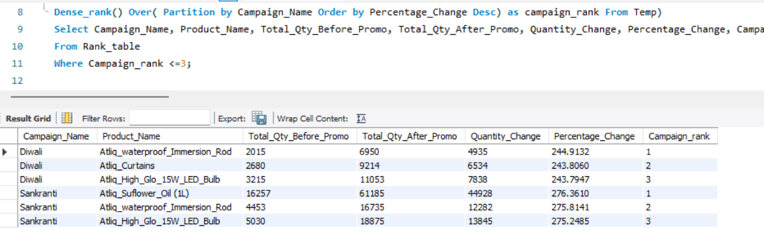
-- ------------------------------------------------------------

-- Q20. Complete Promotional Performance Analysis
-- Create a complete analytical report at the product-category level.

-- For every product, calculate:

-- - Product name
-- - Category
-- - Number of promotional events
-- - Total quantity before promotion
-- - Total quantity after promotion
-- - Quantity change
-- - Percentage change
-- - Revenue before promotion
-- - Revenue after promotion
-- - Revenue change
-- - Average base price
-- - Product rank within its category
-- Use:
-- Quantity Change =
-- Total After - Total Before
-- Percentage Change =
-- ((Total After - Total Before) / Total Before) * 100
-- Revenue Before =
-- SUM(base_price × quantity_before)
-- Revenue After =
-- SUM(base_price × quantity_after)
-- Revenue Change =
-- Revenue After - Revenue Before
-- Then:
-- 1. Rank products within each category by Revenue Change.
-- 2. Return only the top 2 products from each category.
-- 3. Use appropriate handling for division by zero.

With Temp as(
Select P.Product_Name, P.Category, Count(F.Event_id) as Number_of_Promotional_Events, Sum(`quantity_sold(before_promo)`) as Total_Qty_Before_Promo, Sum(`quantity_sold(after_promo)`) as Total_Qty_After_Promo, (Sum(F.`quantity_sold(after_promo)`) - Sum(F.`quantity_sold(before_promo)`)) as Quantity_Change, (( Sum(F.`quantity_sold(after_promo)`)- Sum(F.`quantity_sold(before_promo)`))/ NULLIF(Sum(F.`quantity_sold(before_promo)`),0)*100) as Percentage_Change, (F.Base_Price * F.`quantity_sold(before_promo)`) as Revenue_before_promotion, (F.Base_Price * F.`quantity_sold(after_promo)`) as Revenue_After_promotion, ((F.Base_Price * F.`quantity_sold(after_promo)`) - (F.Base_Price * F.`quantity_sold(before_promo)`)) as Revenue_Change
From Fact_Events as F Join Dim_Products as P
On F.Product_code = P.Product_code
Group By P.Category, P.Product_Name),
Rank_table as
(Select Product_Name, Category, Number_of_Promotional_Events, Total_Qty_Before_Promo, Total_Qty_After_Promo, Quantity_Change, Percentage_Change, Revenue_before_promotion, Revenue_After_promotion, Revenue_Change, Dense_Rank() Over(Partition By Category Order By Revenue_Change Desc) as Rank_products From Temp)
Select Product_Name, Category, Number_of_Promotional_Events, Total_Qty_Before_Promo, Total_Qty_After_Promo, Quantity_Change, Percentage_Change, Revenue_before_promotion, Revenue_After_promotion, Revenue_Change, Rank_products From Rank_table where Rank_products <3;
